My Associate -Revamping to CodeIgniter
Project ID | :
Name of Process | : | My associate Revamping to Codeigniter
Process Details | : | Revamping the My associate page to Codeigniter with all changes mentioned below.
Process Owner | : | Reena
Project Requested By | : | Reena
Project Requested On | : | 10/10/2018
Created By | : | Gauri
Created On | : | 10/10/2018
***************************************************
Module(s) | : | PR
DB Used | : | indianmo_imc_new
Tables used | : | Associates, call_back_ac, service_provider_subscription
Public URLs | : | https://dev.indianmoney.com/appsindianmoney/new_apps/pr/my_associates
Pages ( Full path) | : | - appsindianmoney_gitlab\new_apps\application\controllers\Pr  - appsindianmoney_gitlab\new_apps\application\controllers\Pr_actions  - appsindianmoney_gitlab\new_apps\application\models\Old_associates_model  - appsindianmoney_gitlab\new_apps\application\models\Old_ service_provider_subscription _model  - appsindianmoney_gitlab\new_apps\application\models\Old_call_back_ac_model  - appsindianmoney_gitlab\new_apps\application\views\pr\ my_associates
Logic and functionality | : | Listing page for My associates which will have all details as mentioned below
Special features | : | -
Technology Used | : | Php,Mysql,JS,Jquery
Action Details | :
User Inputs | : | Mentioned Below
Expected output | :

Existing Page
- Link to Service provider.pdf
- Columns shown in table.

Column | Description/Conditions | Actions
ID | A_Id | -
Name | A_Contact_Name | Onclick Redirect To view Profile Page
Mobile | A_Mobile (Masked ) | -
Followup | followup_date | -
Summary | followup_comment | On hover show status and comment
LM | Green LM- aw_balance>0 and mobile_login_date> '2015-06-01 00:00:00'  Red- mobile_login_date> '2015-06-01 00:00:00'  NA- if not in any of above 2 | -
Type | depending on text in followup_type column it will be either FU or PF or NU or PP | On click of Type it will redirect to View profile
Status | depending on A_Status it will be Active Expired or Inactive | -
PAM |  | On click of this will open a popup to send email.
AC | After Claim Date Calls Count (Answered + Not Answered.get the count from call_back_ac table | -
SPSED | Service Provider Subscription Expiry Date  if active associate then depending on subsciption details show the text. | -
SP Status | service_provider_listing =0 that is not listed than provide a button to add | actions/ac/serviceProviderActions.php?act=change_spstatus- to change the status to requested
  - Search filters
- A_Id or Mobile No : A_Mobile
- Name : A_Contact_Name
- FU Date : followup_date
- Type : followup_type
- Called : last_attempted_on
- Sate : A_State
- City : A_City

Proposed page in new platform

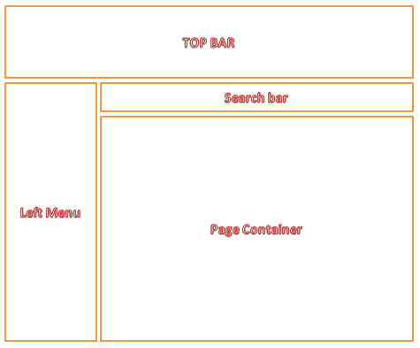

Search Bar
Search by - options
Search Key | : | Data Type
Mobile No | : | ONLY INTIGER
Associate ID | : | ONLY INTIGER
Associate Name | : | Alpha - Part name search also allowed
FU Date | : | Calender
FU Type | : | Drop down - Follow-up | payment Follow-up | payment Prospects
Last Called in | : | Drop down - Days ( 1-15)
State | : | Drop down
City | : | Drop down

- In Search bar I need ICONS as below
  - Payment Followups
  - Payment Prospects
  - Service Provide Doc

Page Container

In this section , we will list below details
A_Id | : | Associate ID . On mouse over of ID masked Mobile number first 3 last 3 digit can show rest should be masked
Associate name | : | Display Name as Capitalize ( means First letter of each word should be in capital) => Provide a click to call button
FU Date | : | DATE First 3 Letter of month Year ( eg : 10 Oct 2018)
FU TYPE | : | NU | FU | PFU | PP => Small images with 20x20 Size. On mouse over show the details
Called On | : | Last Answered Time. On mouse over show Last attempted Date
City | : | Show State Name on mouse Over
LM | : | LM |LM.in - with Version
TCM | : | Total calls made to this associate by this AM after am_date
SPL | : | If subscribed = SPL subscribed | if not Add To SPL  If subscribed on mouse over - show the details

PAM => We can move this to view profile page-> actions

